1. **Apply below mentioned group polices result screenshot is must.**

|  |  |
| --- | --- |
| Organizational Unit | Group Policy |
| IT | deny access to registry & task manager |
| Sales | Deny access to CMD and control panel user  settings |
| HR | Deny access to registry and control panel |
| Domain | Domain password policy is user account should lock after 3 wrong user attempts. After 15 mins user account should be unlocked |

=>

Step1: **Created OU’s & Users in Active Directory User & Computers**

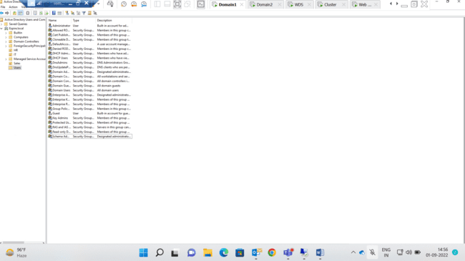

Step2: Enabled Deny access to Task Manager

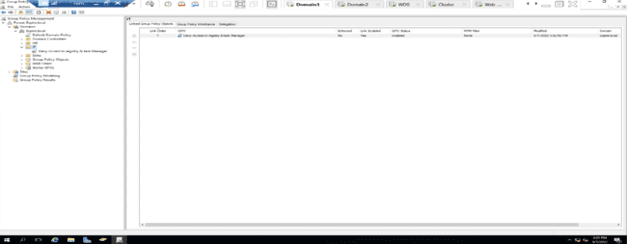

Step3: Enabled Deny Access to task Manager

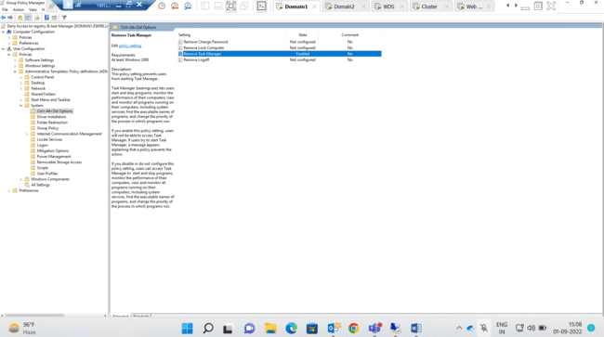

**Step 4:- Enabled Deny access to registry editing tools**

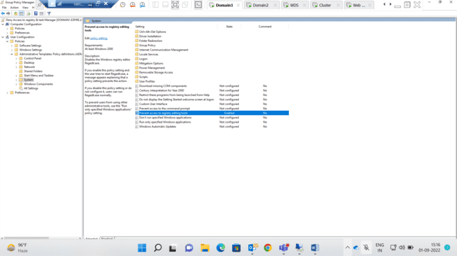

Step5: Enabled Deny Access to Registry & Task Manager in **IT(OU)**

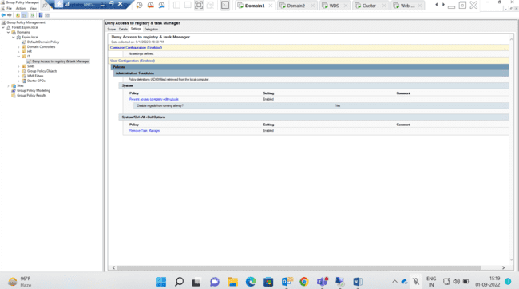

Step6: Successfully enabled deny access to Registry and Task Manager on IT User(Checked on Client machine)

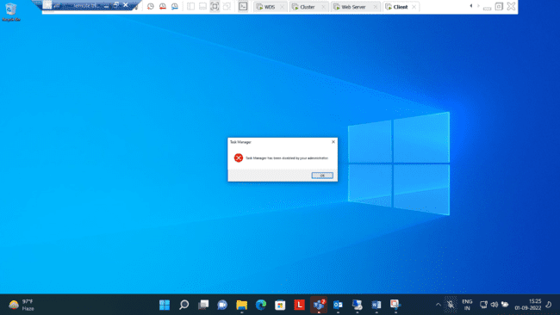

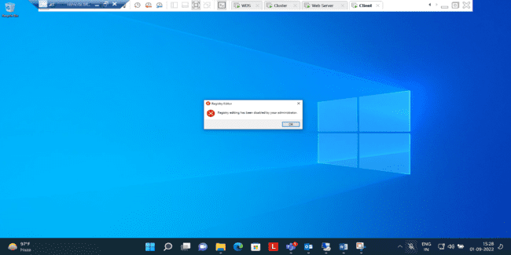

Step7: Enabled Deny Access to CMD

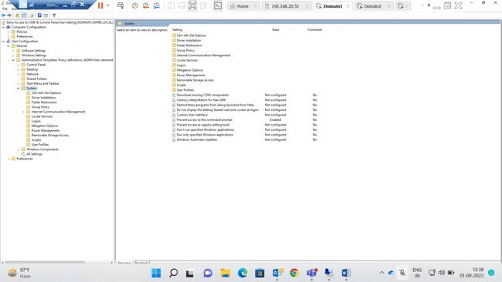

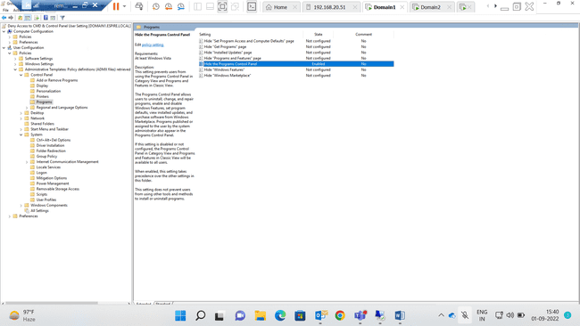

Step8: Enabled deny access to Control panel & CMD **Sales(OU)**

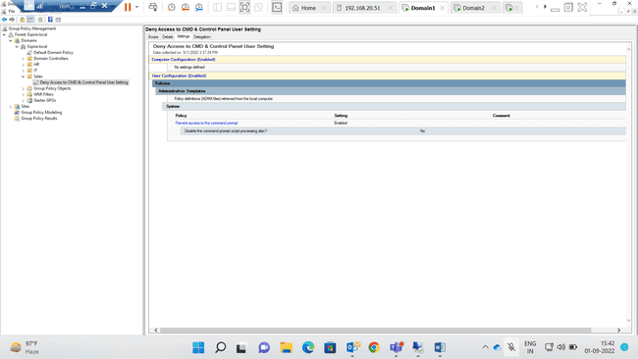

Step 9:- Successfully Enabled Deny access to cmd and Control panel (Checked with sales on user on client machine)

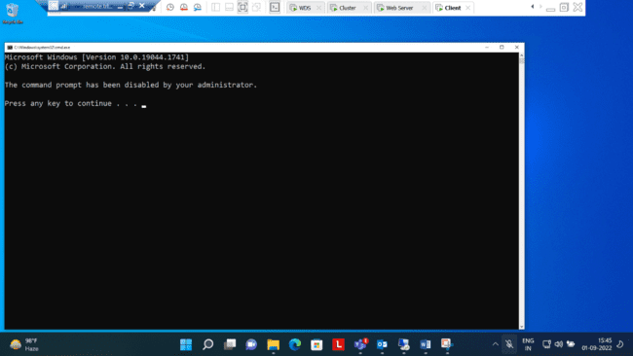

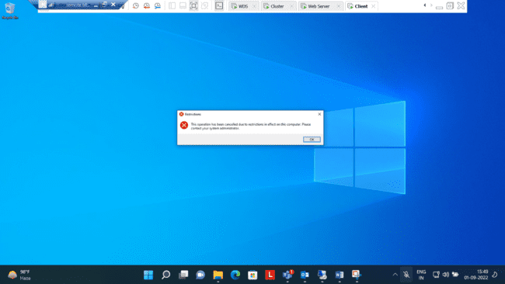

Step10:- Enabled deny access to Control panel & Registry In **HR(OU)**

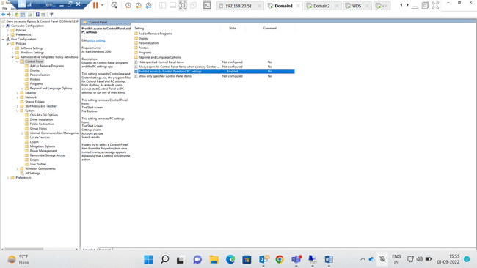

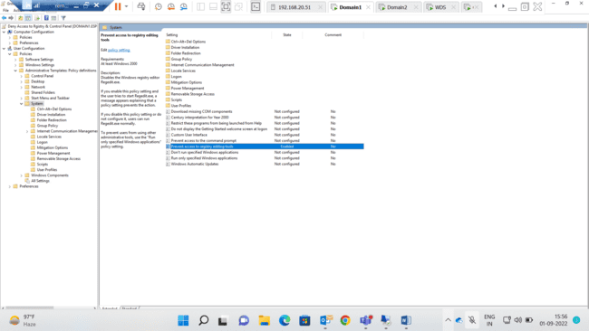

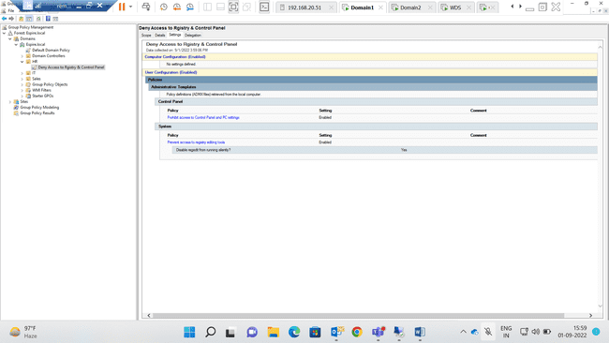

Step11:Successfully Enabled Deny access to Control panel & Registry (Checked with HR user on client machine)





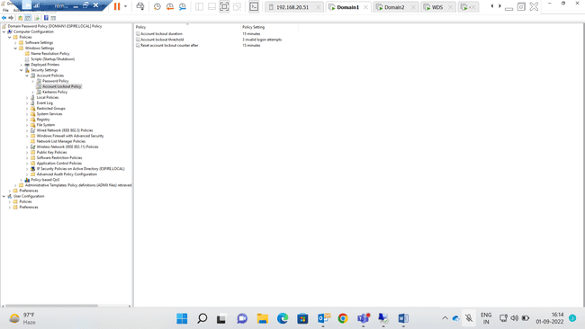

Step12: Domain password policy is user account should lock after 3 wrong user attempts. After 15 mins user account should be unlocked

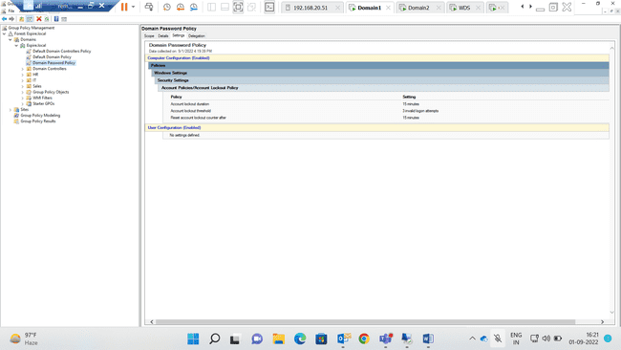

***--Question 1 Completed--***

1. Apply below mentioned configuration using FSRM. Create a folder for IT as mentioned below. Implement and apply the following FSRM Policy.

|  |  |
| --- | --- |
| Folder | FSRM policy |
| IT | 10 MB hard Quota, can’t save  mp4 files |
|  |  |

=>

Step 1 :- Created a new folder name **IT** in C drive

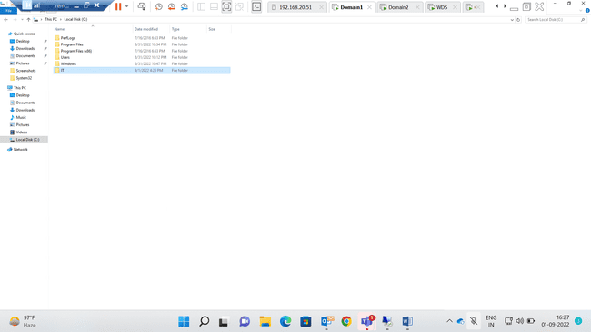

Step 2 :- Created quota template & Applied file Screening(Audio & Video) on IT folder in File server resource manager.

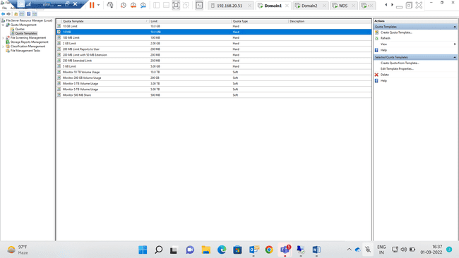

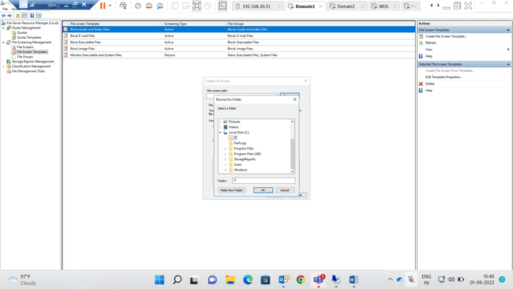

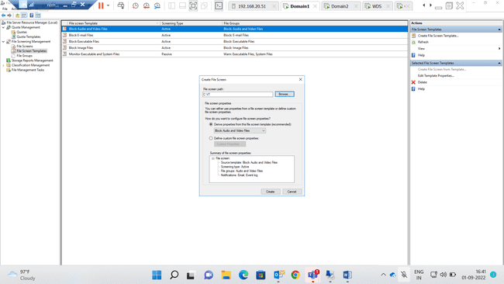

Step 3:- Successfully applied File Screening template (Audio and video) i.e. cant save Mp4 file IT folder.

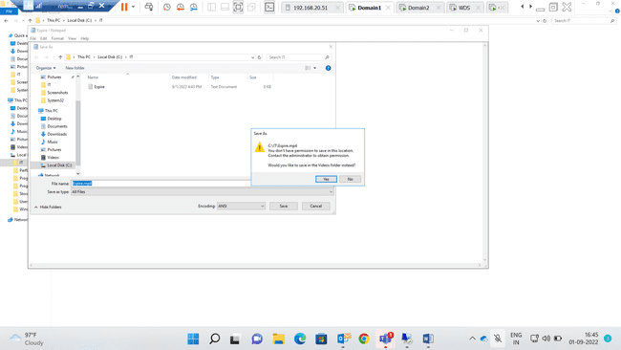

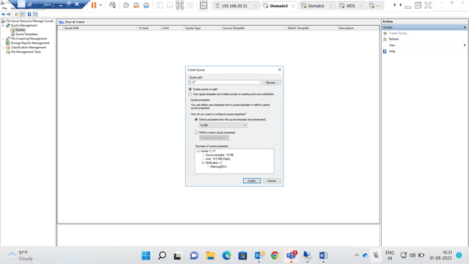

Step 4:- Created Quota for IT folder With maximum size of 10mb & also Successfully applied on IT folder.

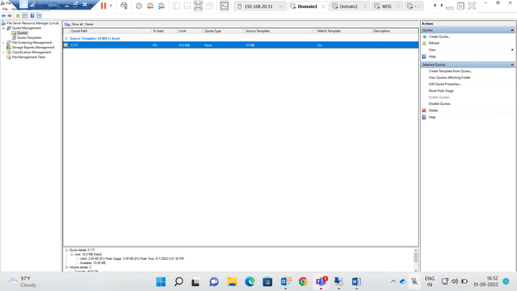

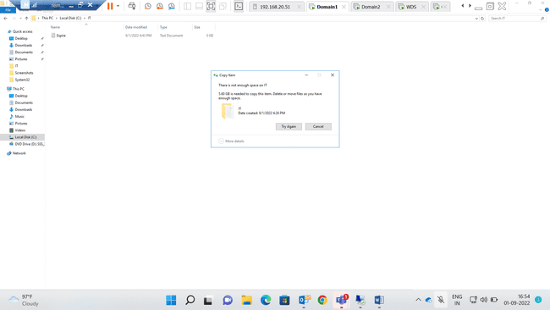

--Question2 Completed--

1. **Perform Backup of a Server Folder into a shared folder in your Client Machine. Delete your server folder and Recover the folder from that backup.**

**=>**

**Step1:** Created Backup Schedule once in a day using shared folder in domain 2

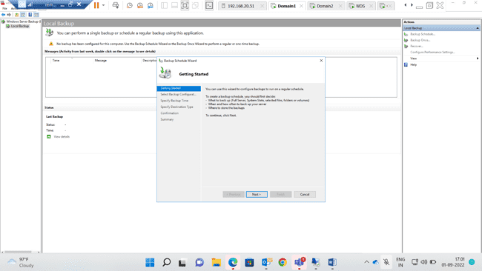

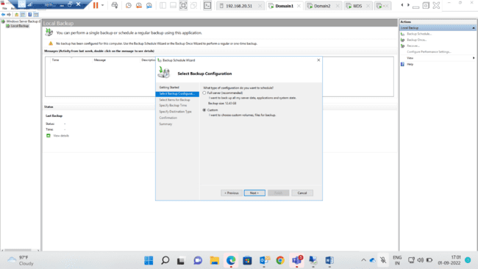

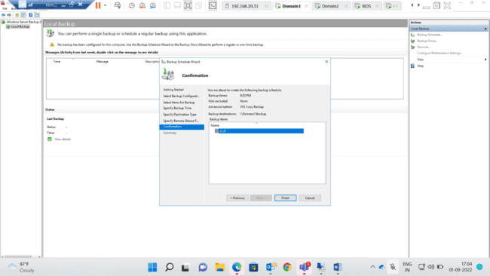

**Step2:-** Created Backup once(Immediate) in shared folder i.e. Backup(folder name)

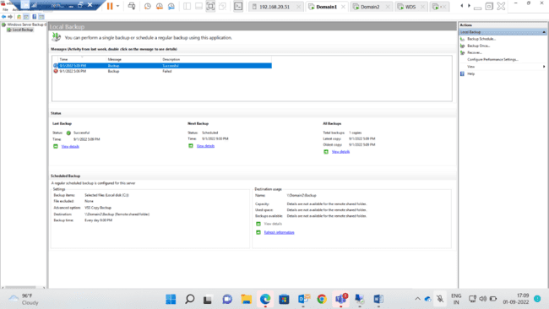

Step3: Deleted Files from IT in Domain1

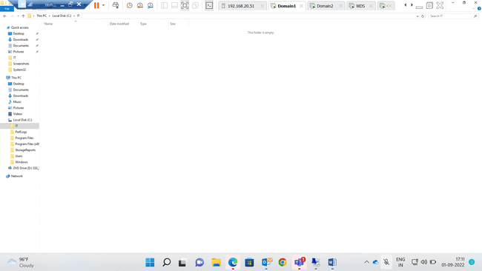

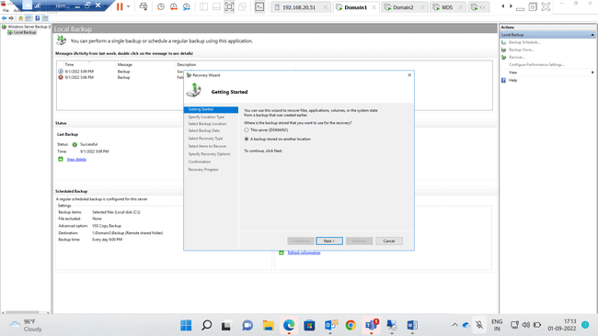

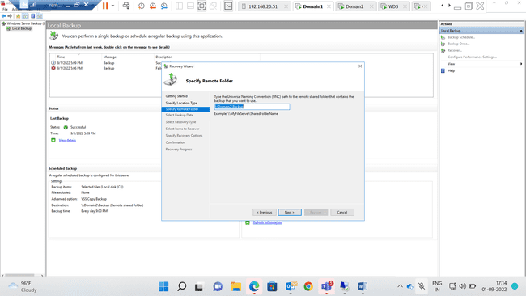

Step4 :- Selected the Backup folder and time from remote folder

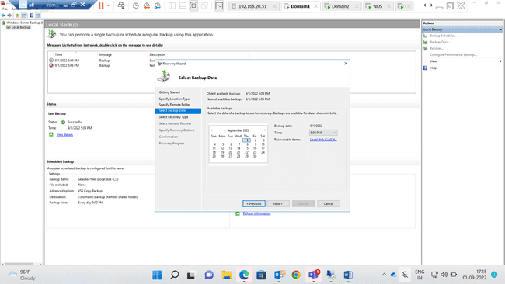

Step5: **Selected item(Folder) to be recovered in Domain1**

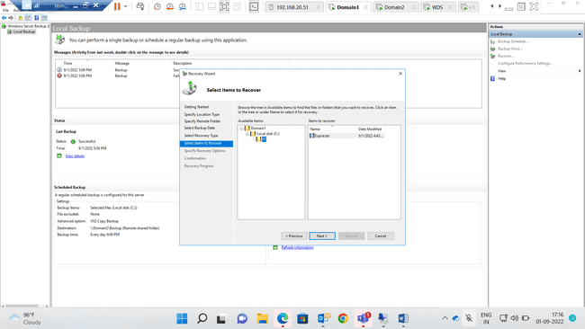

**Step 6 :- Recovered Successfully the files from shared folder(Backup) to original folder(IT)**

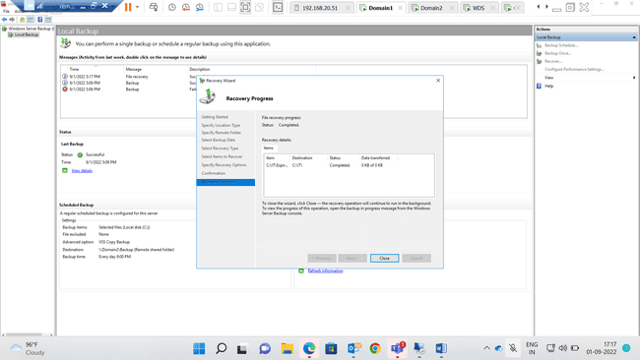

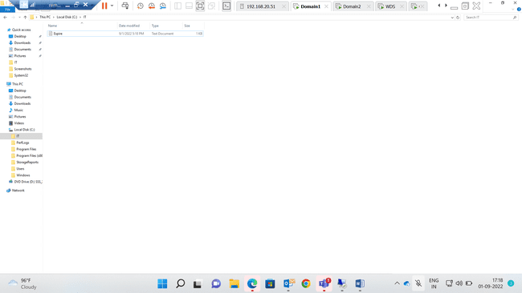

**---Question3 Completed---**

1. **Implement network deployment of a Windows 7 OS to clients. Ensure you don’t miss to capture the screenshot of IP address display in the client when loading from WDS. Verify if it is working (Verify if it is reaching to 1% progress of OS installation).**

**=>**

**Step1: Selected the path for remote installation folder location**

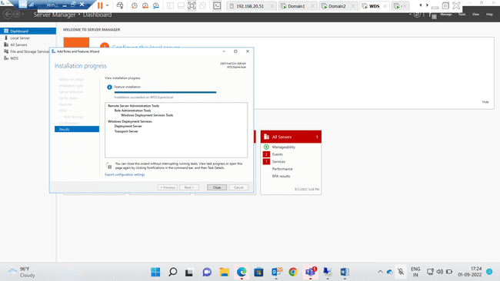

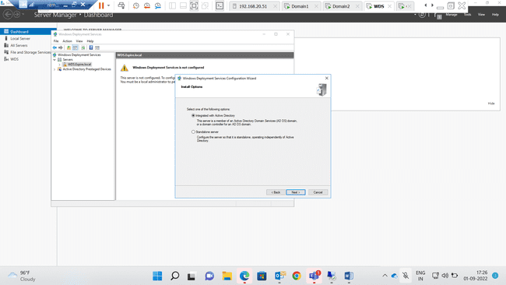

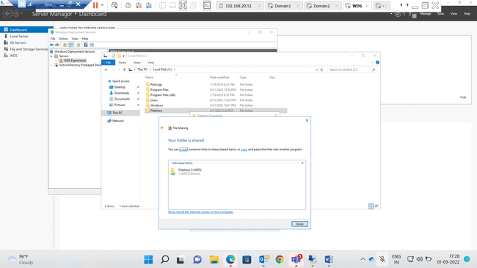

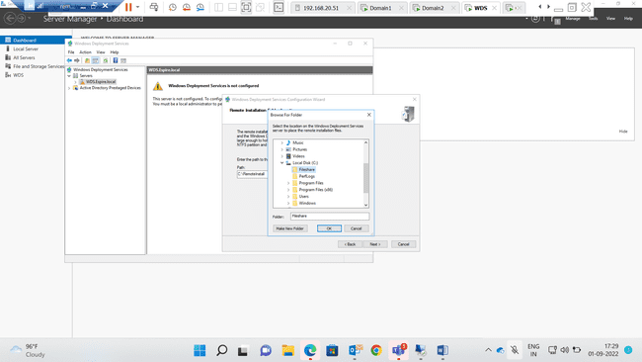

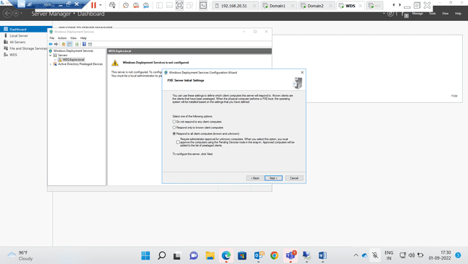

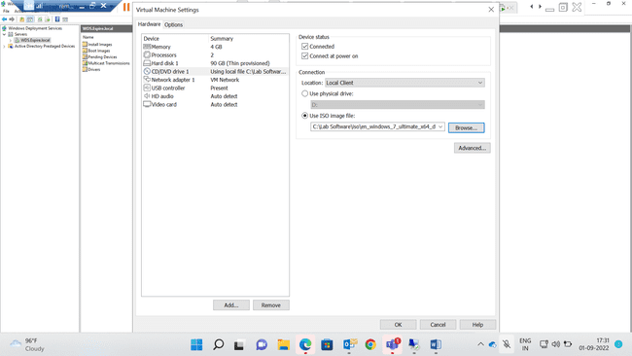

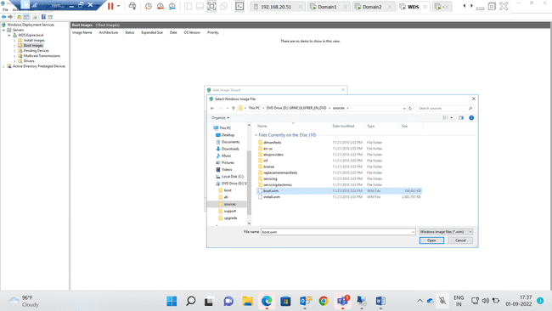

**Step2: Boot Images & Install images added successfully**

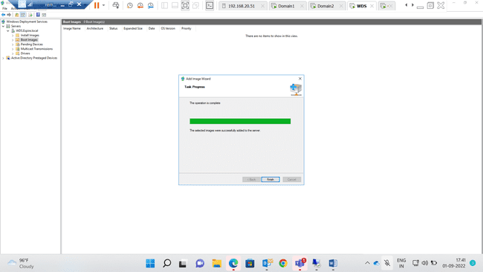

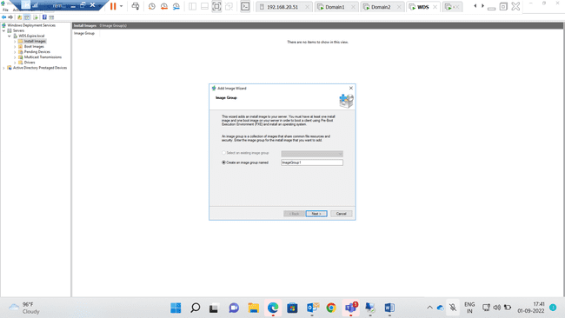

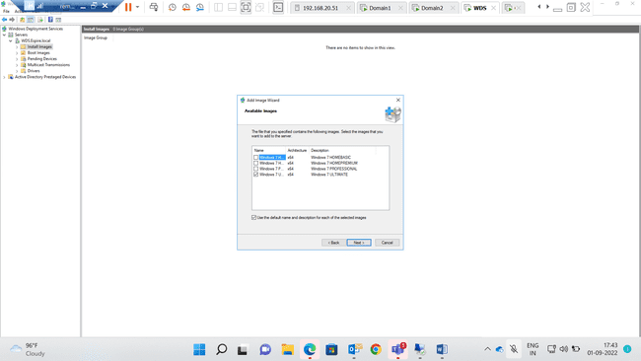

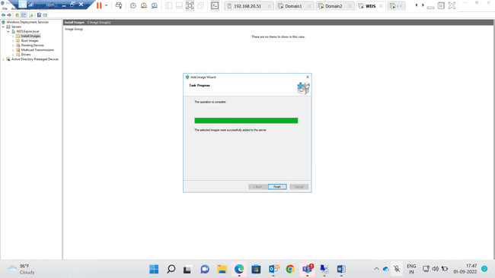

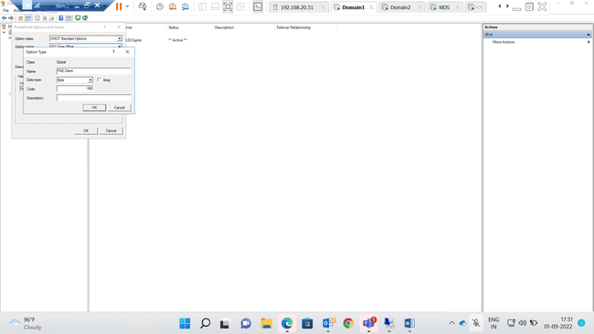

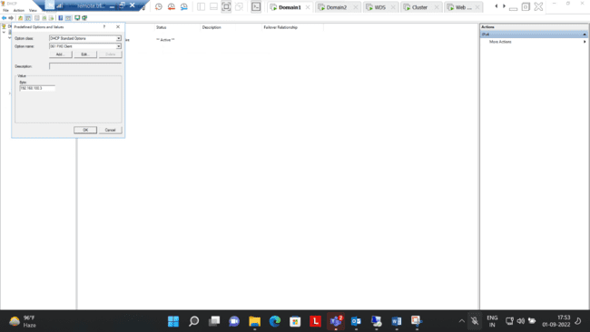

Step3: Fetching CD drive from WDS(192.168.100.3)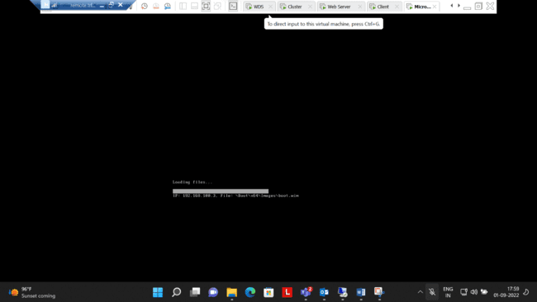

Step4: **Successfully Operated installation process**

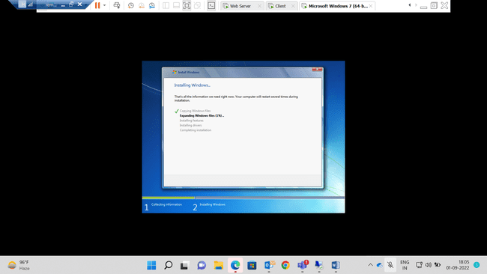

**---Question4 Completed---**

**5.Transfer all FSMO roles to the ADC using GUI and transfer back to DC using Powershell. Verify if it worked using command line.**

**=>**

**Step1:** Master Role for RID, PDC, Infrastructure changed to Domain 2 from Domain 1

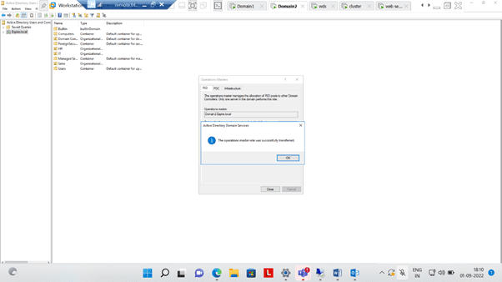

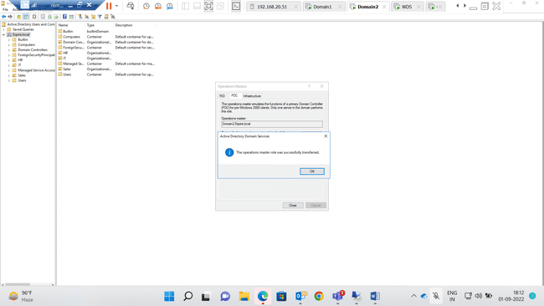

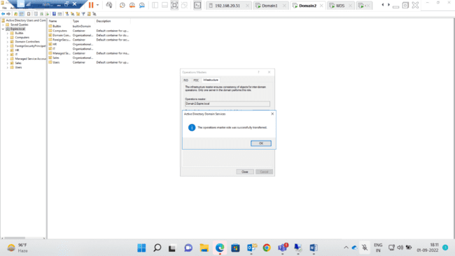

Step3: Changed all controls to Domain2 from Domain1

Step 2 :- Changed all controls to Domain2 from Domain1

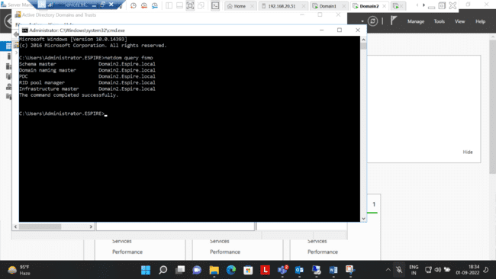

Step3: Implemented Changing controls to domain 1 from domain 2 using powershell.

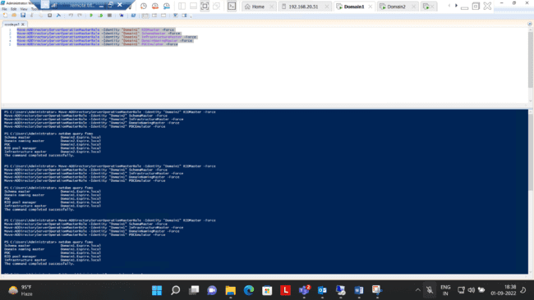

Step4: Checked all controls changed to domain 1 from domain 2 using CMD

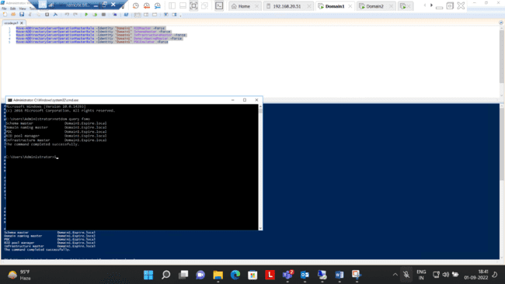

**---Question5 Completed---**

**6.Perform installing and Configuring IIS, Create a website with a webpage, Test if it is accessible from the client, protect the Website With SSL.**

**=>**

**Step1:**Installing Web server(IIS) in Cluster

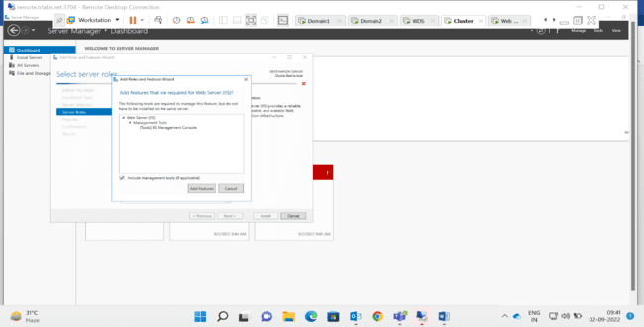

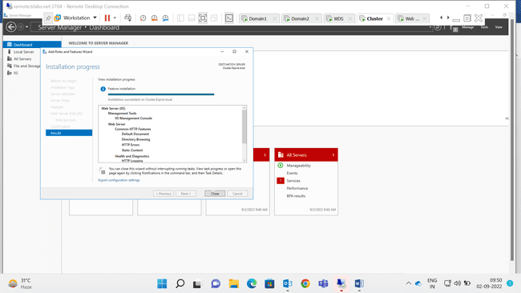

**Step2:-** Added Web Sever(IIS) Role in Web Server

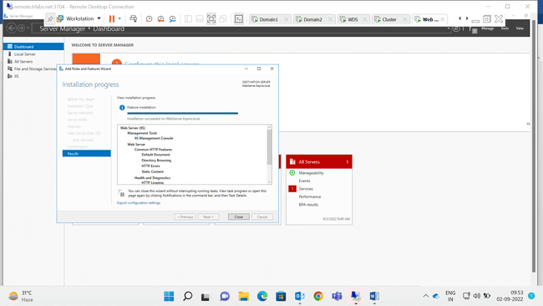

Step3: Added Active Directory Certificate Services in Domain1

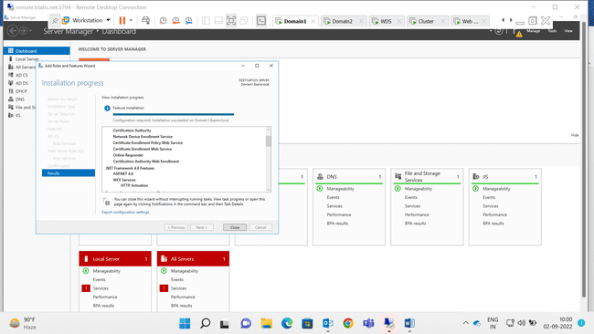

Step4: Selected Roles Services to Configure

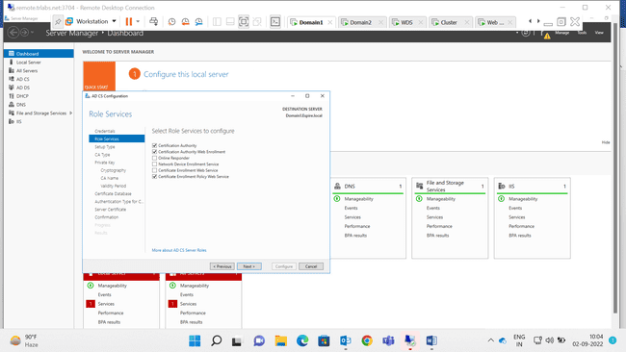

Step5:

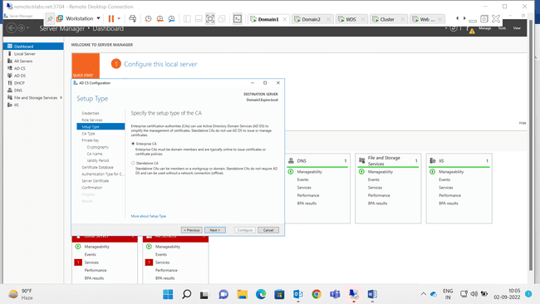

Step6:

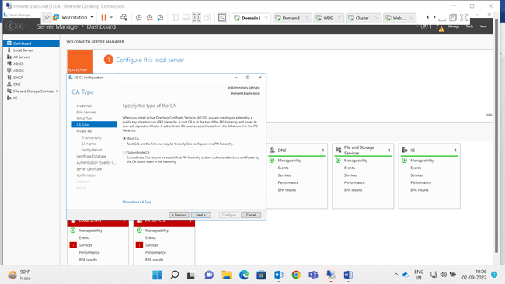

Step7: Cryptography for CA

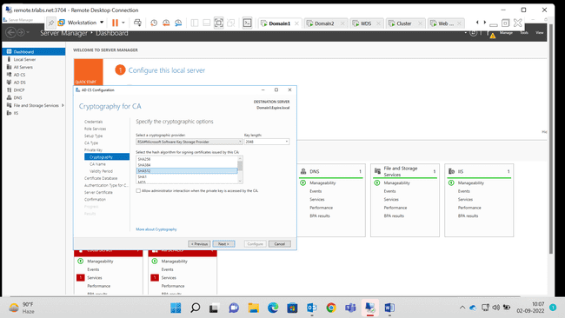

Step8:

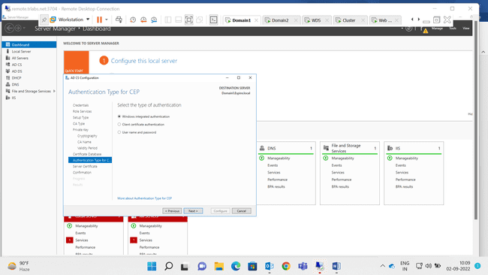

Step9:

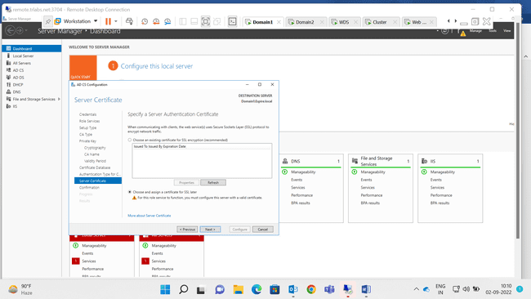

Step10: Configuration Successful of AD CS

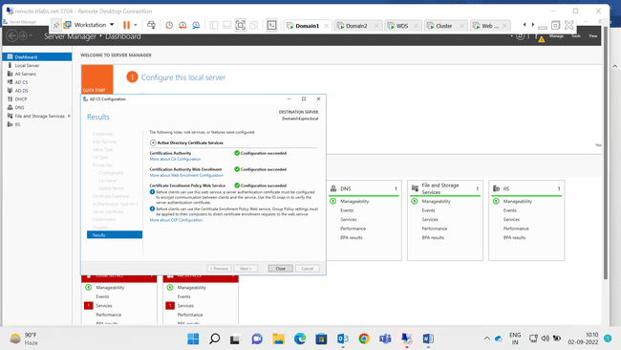

Step11: Online Certificate Authority

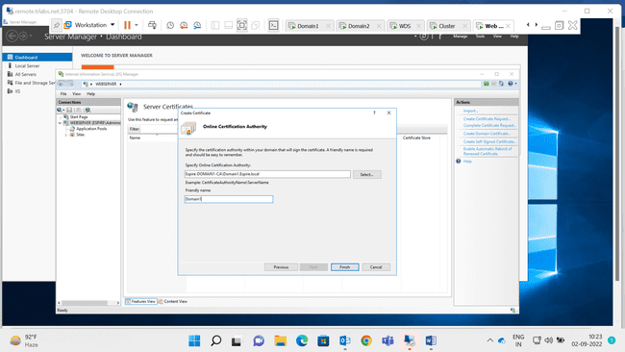

Step12:

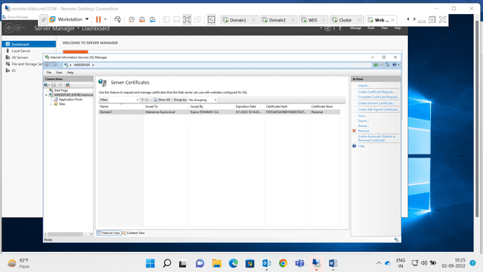

Step13:Certificate Issued by Domain1 to Webserver

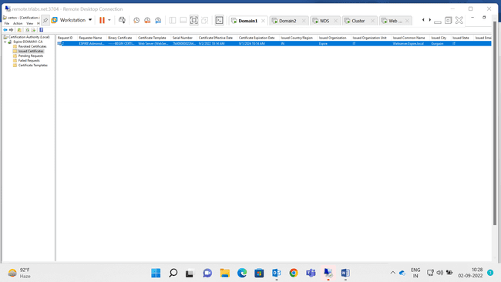

Step14:

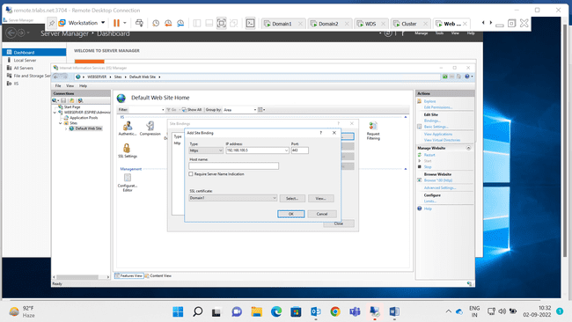

Step15:Binding Done in Webserver for(Https)

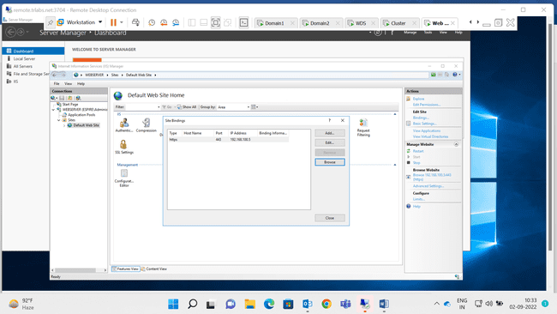

Step16:

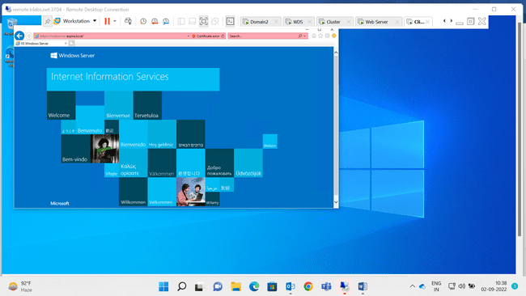

Step17: Successfully Checked that Web Server Site Can be Access from Client Machine With Another User with HTTPS Security i.e.(SSL)

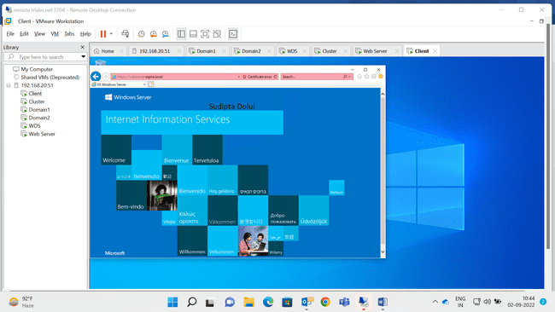

--Question6 Completed—

**7. Perform installing and Configuring Network load balancing feature , add two web servers and show the result of load balancing when both the web server is on and if one web server is down.**

=>

Step1: Installed Feature of Network Load Balancing in Cluster

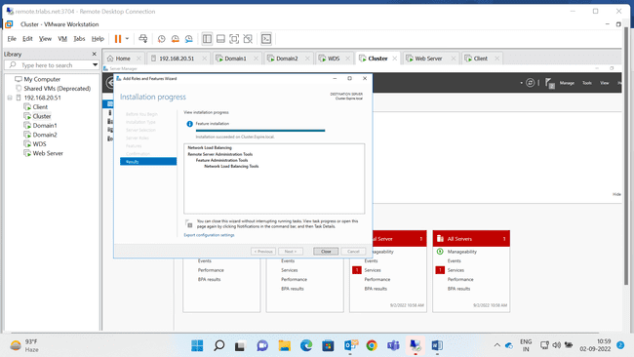

Step2: Installed Feature of NLB in Webserver

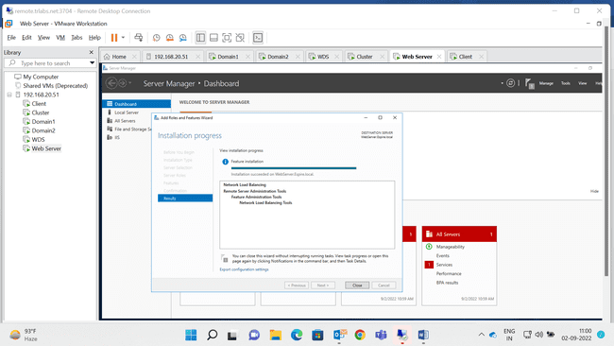

Step3: Created Host(A). i.e. 192.168.100.4; 192.168.100.5; & NLB (192.168.100.55)

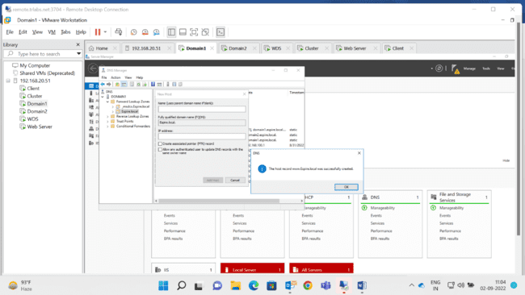

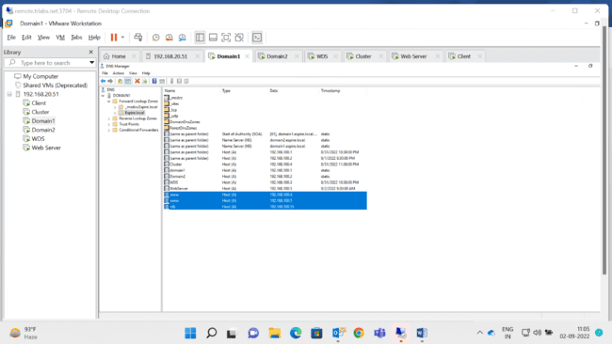

Step4: Creating New Cluster Connected for Web Server

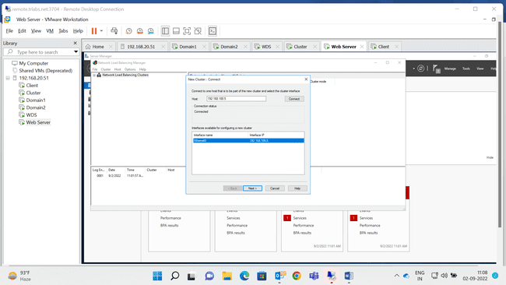

Step5: Added the Cluster IP Address (NLB- 192.168.100.55)

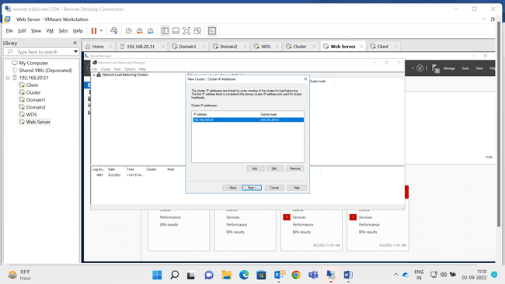

Step6: Cluster Parameter

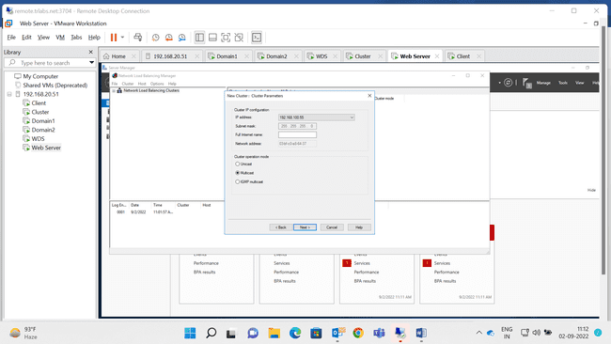

Step7:

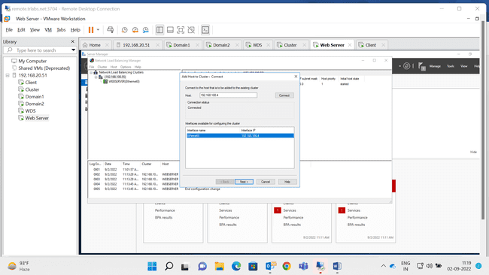

Step8: Both the Machine Successfully connected with Cluster

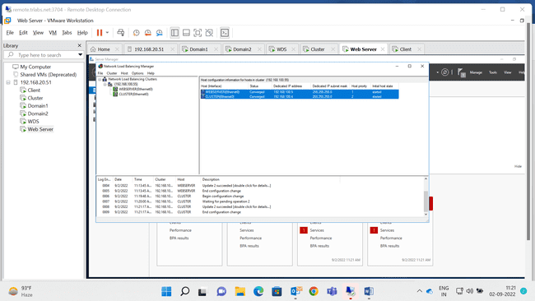

Step9: Cluster can be accessed through client (192.168.100.5) suspending Web Server

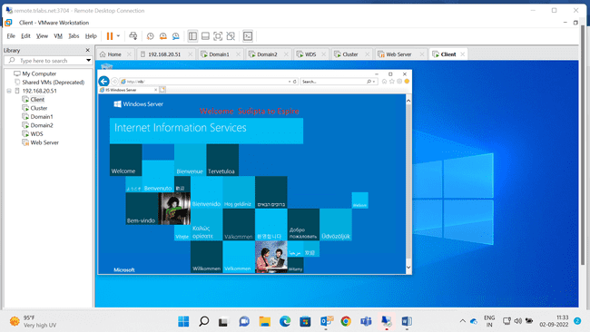

Step10: Webserver Can be Accessed through client(192.168.100.4) Suspending Cluster

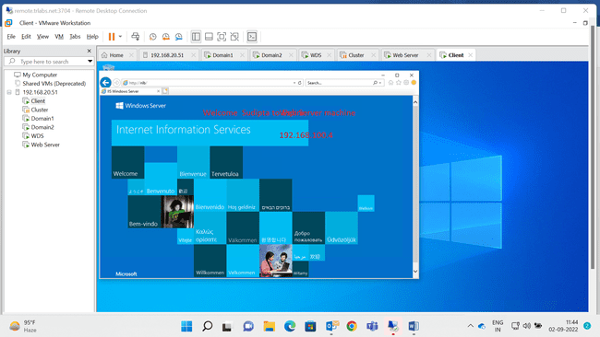

--Quesstion7 Completed--

8. **Implement ADC Replication. Verify if it is working.**

=>

**Step1: Create two Subnet IP**

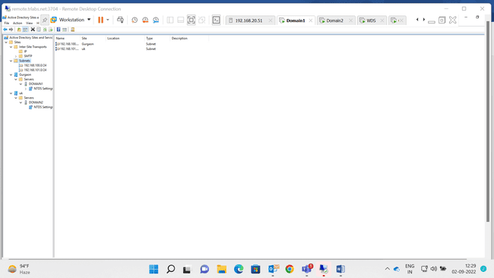

**Step2:**

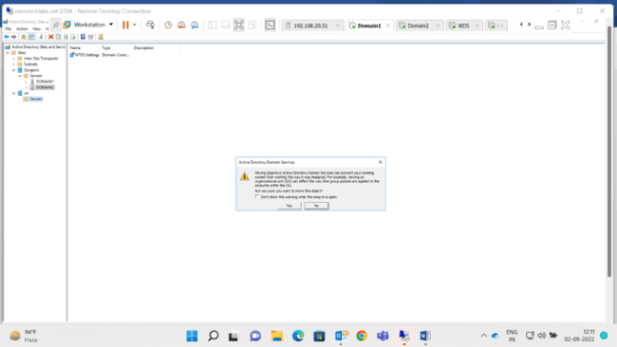

**Step3:**

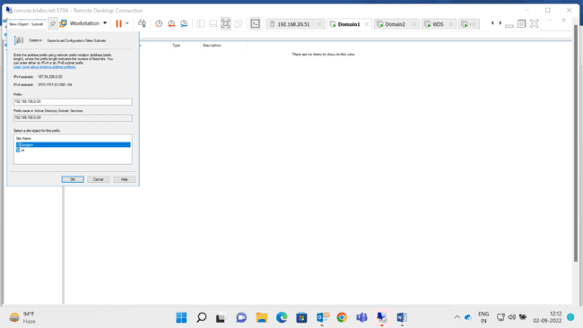

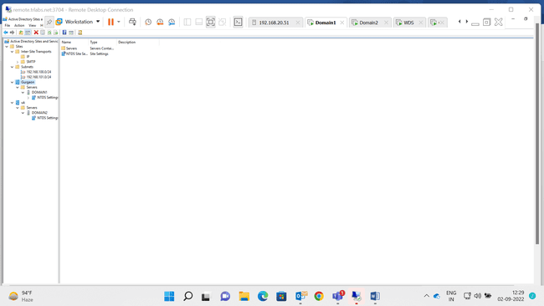

**Step4:**

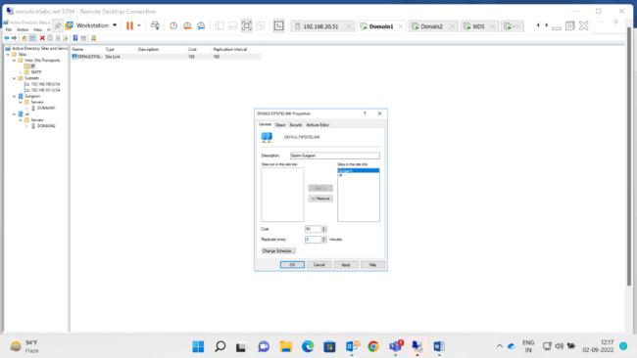

**Step5: Replication Not Available this Working time**

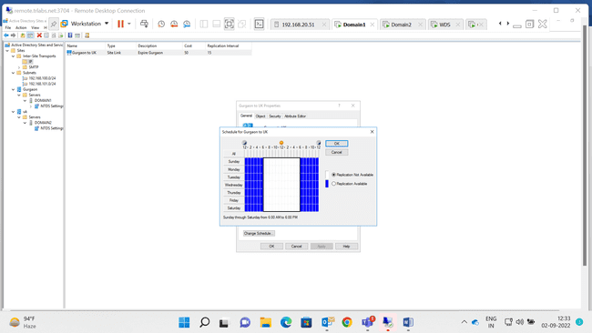

**Last step: All process are done & now its working**

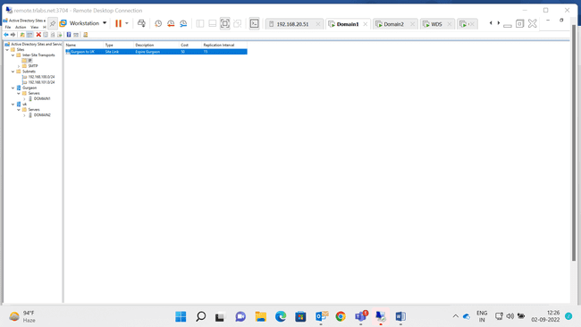

**--Question8 Completed—**

**--All Question are Completed--**